A1361-MEX-Teotihuacan-Figure-Male-Seated-Basalt-1400 CE

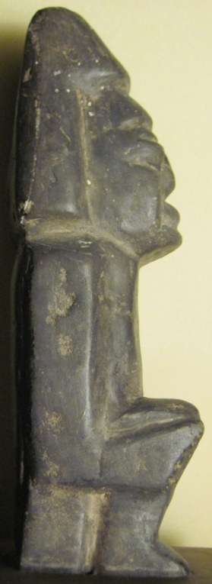 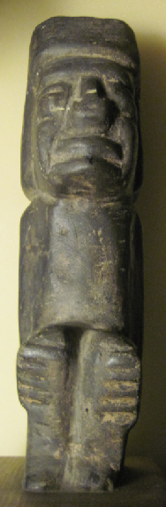 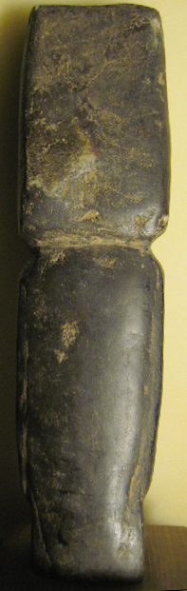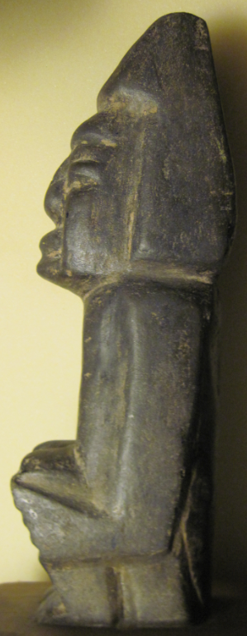

Figs. 1-4. Teotihuacan-Figure-Male-Seated-Basalt-1400 CE

**Case no.: 9**

**Accession Number: A1361**

**Formal Label:** Teotihuacan-Figure-Male-Seated-Basalt-1400 CE

**Display Description:**

The figure is an élite male personage seated on a stool as though receiving a visitor or espousing a dictum. The humanoid form is defined by deep notch cuts which are abraded or rounded to give the body limbs with rigid definition with its arms grasping the knees. The stool on which he is seated is unadorned and suggests the sense of implacability. The headdress is a truncated rectangle with side pieces covering the ears. In this it reminds one of the Mezcala tradition, since in the Teotihuacan style there would be ear spools to indicate élite status. There is a hint of a cape covering the back, again without adornments.

**Geographical Area:** Teotihuacan

**Map:**

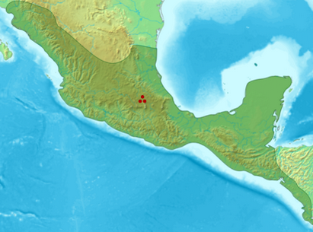

Fig. 5. Location of Teotihuacan. From https://upload.wikimedia.org/wikipedia/commons/thumb/1/1c/ES-Mesoam%C3%A9rica.png/428px-ES-Mesoam%C3%A9rica.png

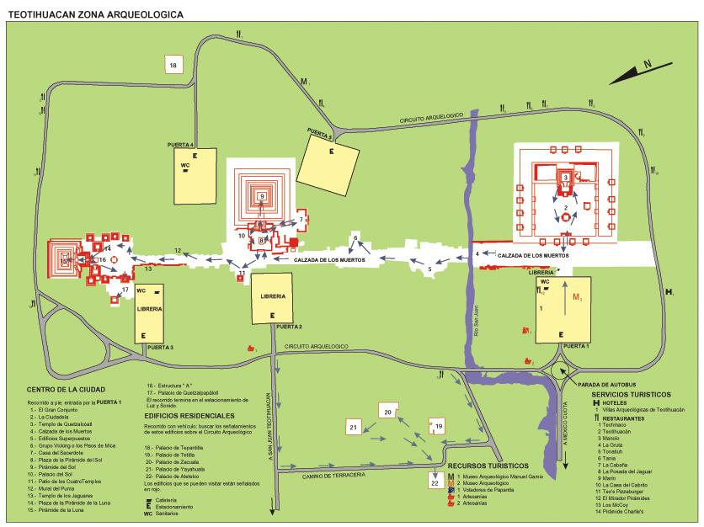

Fig.4. Map of Teotihuacán From http://mapas.owje.com/img/Mapa-Zona-Arqueologica-de-Teotihuacan-Edo-Mexico-8761.jpg

**GPS coordinates:** 19°41′33″N 98°50′38″W

**Cultural Affiliation:** Aztec

**Medium:** basalt

**Dimensions:** H 24.5 cm; 9.75 in

**Weight: n/a**

**Condition: original**

**Provenance:** Teotihuacan valley, pre 1961

**Discussion:**

The influence of Mezcala stylistics on Teotihuacan features has never been attempted in detail. The present example found in the Teotihuacan valley prior to 1961 is a good example. The attempt to use the incision style promoted by the Mezcala figurines has been applied but with some overlying influences of the Teotihuacan Aztec stylistics. In this manner, the result is a not so-pleasing mixture of the two. However, on a cultural level it is important for it marks the Epi-Teotihuacan period when the disintegration of Teotihuacan culture was proceeding without the control over stylistic conformability to either Mezcala or Teotihuacan artisanal codes. The result is an unusual hybrid of the two.

The original name of Teotihuacan was associated with *puh*, or "Place of Reeds" (Schele and Mathews 1998: 39). *Teōtīhuacān* was given by the Nahuatl-speaking Aztecs ca 1200 CE after the fall of the city around 550 CE. Its Nahuatl meaning is "place of those who have the road of the gods,"[[6]](https://en.wikipedia.org/wiki/Teotihuacan#cite_note-6) because the Aztecs believed that the gods created the universe at that site. “Place of Reeds,” is the original name of the city which was constructed within the swampland in the Basin of Mexico from which the first settlers (ca 200 BCE), who were probably multi-ethnic, raised floating beds or *chinampas*, that allowed agricultural productivity as well as security again invaders (Pollard, Rosenberg, and Tignor 2015: 292) and water channels for canoe transportation around the city. By 100 CE the first phase of the Pyramid of the Sun was completed and by 200 CE the second phase attained its final height, making it the third largest pyramid in the world (Aston and Taylor 1998: 43). This is a seminal event that indicates a high level of religious, ritual and astronomical development among the people. Therefore when the city declined ca 550CE due to multiple factors (climatic, political and social) the effect on the artisans who represented the investment of expendable wealth declined a well, affecting statuettes such as the present example.



Fig. 5. Location of Teotihuacan. From https://upload.wikimedia.org/wikipedia/commons/thumb/1/1c/ES-Mesoam%C3%A9rica.png/428px-ES-Mesoam%C3%A9rica.png

**Date or Time Horizon:** 400-700 CE

Geographical Area: Teotihuacán, 30 mi NE of Mexico City

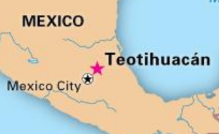

Fig. 2. <http://media-1.web.britannica.com/eb-media/33/19733-004-B8F4AC9B.jpg>

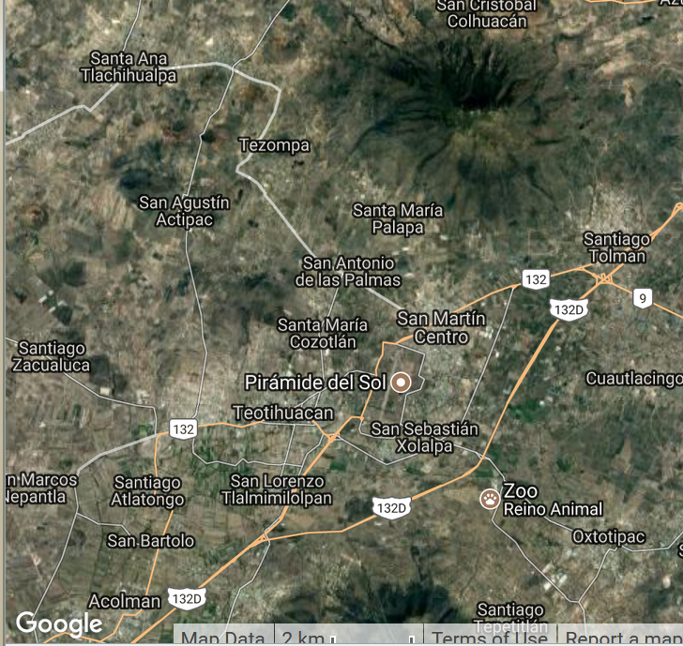

Fig. 3. The archaeological site is located in what is now the San Juan Teotihuacán municipality in the State of México, approximately 40 km (25 mi) northeast of Mexico City. The site covers a total surface area of 83 square km (32 sq mi) and was designated a UNESCO World Heritage Site in 1987. It is the most visited archaeological site in Mexico. Map from Google.

**References:**

Aston, Michael and Tim Taylor. 1998. *Atlas of Archaeology*. London: Dorling Kindersley.

Brettell, Richard R. 1974. “Mezcala Stone Sculpture in the Olsen Collection,” *Yale University Art Gallery Bulletin*, 35(1, Summer): 14-19.

Gay, Carlo and Frances Pratt. 1992. *Mezcala: Ancient stone sculpture from Guerrero, Mexico.* Geneva: Balsas Publications

Millon, René. 1993. "The Place Where Time Began: An Archaeologist's Interpretation of What Happened in Teotihuacan History". In Berrin, Kathleen and Esther Pasztory, eds. Teotihuacan: Art from the City of the Gods. New York: Thames and Hudson. pp. 16–43.

Pollard, Elizabeth; Rosenberg, Clifford; Tignor, Robert. 2015. Worlds Together Worlds Apart Volume 1 Concise Edition. New York: W.W. Norton & Company.

Schele, L. and Mathews, P. 1998. *The code of kings*. New York: Scribner.

[Teotihuacan: Pyramids of the Sun and the Moon, Heilbrunn Timeline of Art History, The Metropolitan Museum of Art, retrieved October 29, 2016](http://www.metmuseum.org/toah/hd/teot2/hd_teot2.htm,)